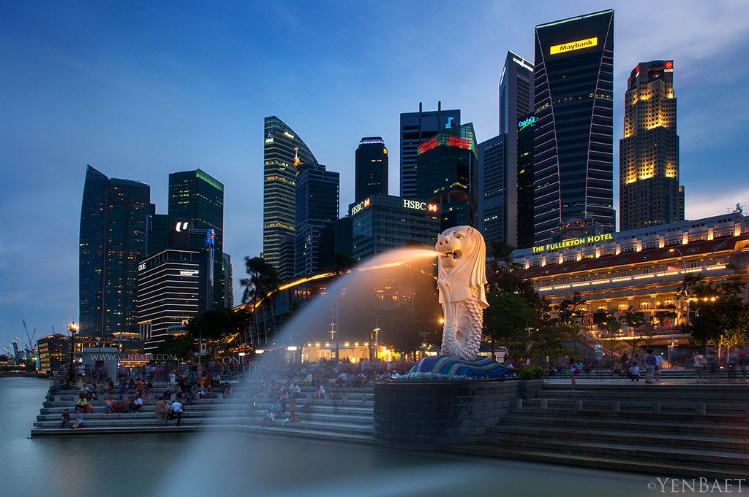
Report by ANMOL DEDHA
for trouver trade RESEARCH & TECHNOLOGY ltd.

ECONOMY OF SINGAPORE

Anmol Dedha |8882645762 |anmoldedha1191@gmail.com

REPORT
In this report we are analyzing 3 major sector of Singapore’s economy Railways, Industrial and agriculture. Our major focus is on Business side of these sectors, for example factors like-market Size, potential growth, future opportunity and other prospect in sectors.

CONTENTS
- Introduction
- Economy Structure Of Singapore

- Sectors
- Railways
- Industrial
- Agriculture

- Conclusion And Opinion
- Reference


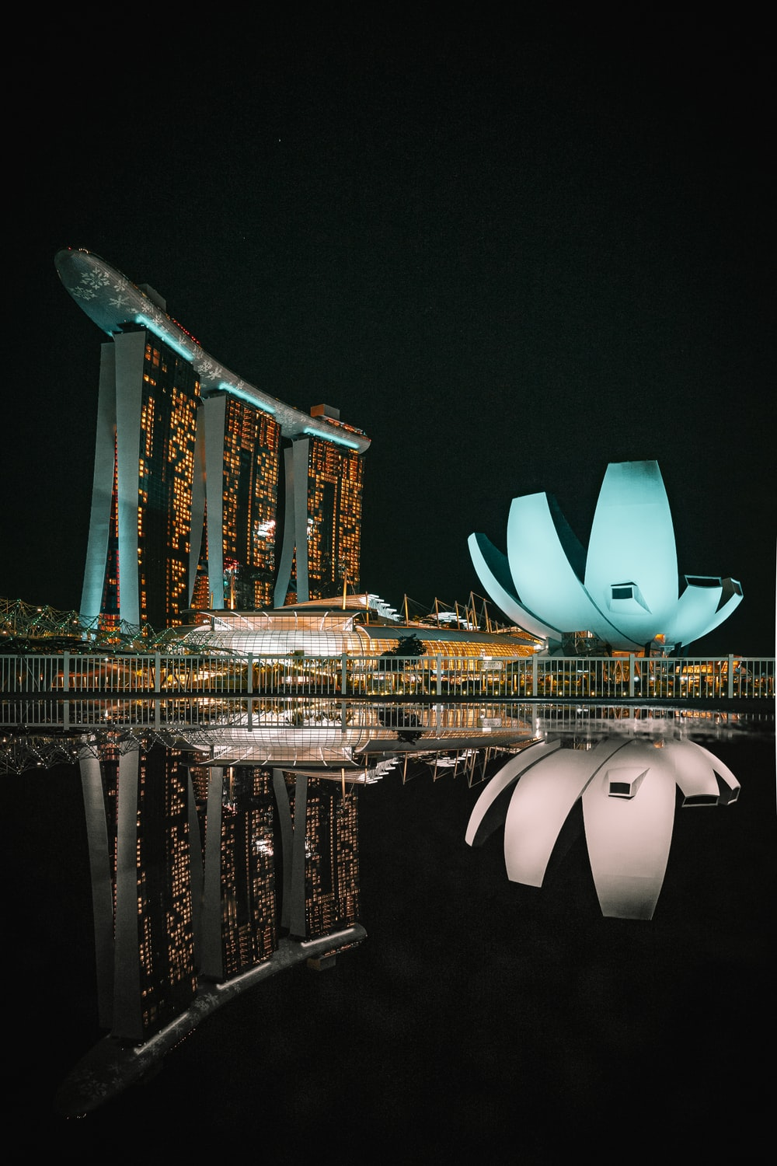

Introduction

SINGAPORE’S ECONOMY

The economy of Singapore is a highly developed free-market economy with characteristics in which the state plays a strong directive role.
Singapore's economy has been ranked as the most open in the world the joint 4th-least corrupt, and the most pro-business. Singapore has low tax-rates and the second-highest per-capita GDP in the world in terms of purchasing power parity (PPP).
Alongside the business-friendly reputation for global and local privately held companies and public companies, various national state-owned enterprises play a substantial role in Singapore's economy.
Alongside the business-friendly reputation for global and local privately held companies and public companies, various national state-owned enterprises play a substantial role in Singapore's economy. Singapore relies on an extended concept of intermediary trade to entrepôt trade, by purchasing raw goods and refining them for re-export in order to sustain its high levels of export-oriented industrialization, such as in the wafer-fabrication industry and in oil refining. Singapore has a strategic port which makes it more competitive than many of its neighbors in carrying out such entrepôt activities.


The Port of Singapore is the second-busiest in the world by cargo tonnage and is the busiest transshipment port in the world. Singapore is also a regional, continental and global hub for the management and operations of various MNCs, with its strategic location in close proximity with other Asia-Pacific markets, along with its advanced connectivity and infrastructure as an airline hub and maritime port with a diverse array of destinations, fiber-optic communications, efficient road transport and public transport as well as its immigration policies being receptive to human capital. In addition, Singapore is a popular international tourist destination for various types of tourism, such as business tourism, MICE (Meetings, Incentives, Conferences, Exhibitions) tourism, medical tourism and urban tourism.

The country's main exports include electronics, chemicals and services. Singapore is the regional hub for wealth management. Water is scarce in Singapore, and so it has invested in hydraulic engineering and desalination to reduce the country's dependence on untreated imported water. therefore, it is defined as a precious resource. Small and medium-sized enterprises (SMEs) are the backbone of the Singapore's economic landscape. SMEs contribute about 40% of Singapore's nominal GDP and employs 70% of Singapore's total workforce of 3.35 million. Singapore has limited arable land, and therefore the country has heavily invested in agrotechnology parks such as vertical hydroponic farms for agricultural production. As a result, Singapore imports 90% of its food supply and has a wide variety of supplier countries in order to achieve its food security.
Singapore lacks significant natural resources, hence human resources is a pivotal issue for the health of the Singaporean economy
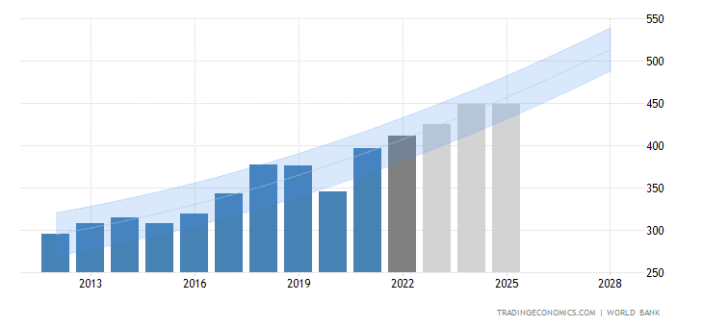

GDP OF SINGAPORE

GDP in Singapore is expected to reach 425.00 USD Billion by the end of 2022, according to Trading Economics global macro models and analysts’ expectations. In the long-term, the Singapore GDP is projected to trend around 449.00 USD Billion GDP in 2024.

YEAR | GDP (in $ Billions)
2012 | 295.09
2013 | 307.58
2014 | 314.85
2015 | 308
2016 | 318.83
2017 | 343.19
2018 | 377
2019 | 375.47
2020 | 345.3
2021 | 396.99
2022 | 425
2023 | 433
2024 | 440.4
2025 | 455.5

RAIL TRANSPORT  - SMRT Trains Limited.  - SBS Transit Limited  MANUFACTURING &  TRANSPORTATION  - Innovation  - skilled workforce  - well-developed infrastructure  AGRICULTURE  - Fishing  - Food crops  - Flower crops |  | SECTORS

Rail transport in Singapore

Rail transport in Singapore mainly consists of a passenger urban rail transit system spanning the entire city-state: a rapid transit system collectively known as the Mass Rapid Transit (MRT) system operated by the two biggest public transport operators SMRT Trains (SMRT Corporation) and SBS Transit, as well as several Light Rail Transit (LRT) rubber-tired automated guideway transit lines also operated by both companies.

INDUSTRIAl in Singapore

Singapore has built a strong and diverse manufacturing base, with leadership positions in sectors such as aerospace, electronics, biomedical sciences and precision engineering.
Manufacturing remains a significant contributor to Singapore’s economy, contributing about 20 per cent to its GDP. Singapore is also the fourth largest global exporter of high-tech products.

AGRICULTURE in SINGAPORE

Agriculture in Singapore became heavily reduced as early as 1987. In that year, there were officially 2,075 farms in the country, covering an area of 2,037 hectares (5,030 acres), an average of less than 1 hectare (2.5 acres) per farm.

Before modernized development, Orchard Road was a stretch of agricultural orchards. As with many other areas, the farms there soon began to disappear, and Singapore became more reliant on overseas imports. One major issue in 1984 was the health concerns with pig farms in Singapore, concerning the pollution of the environment.

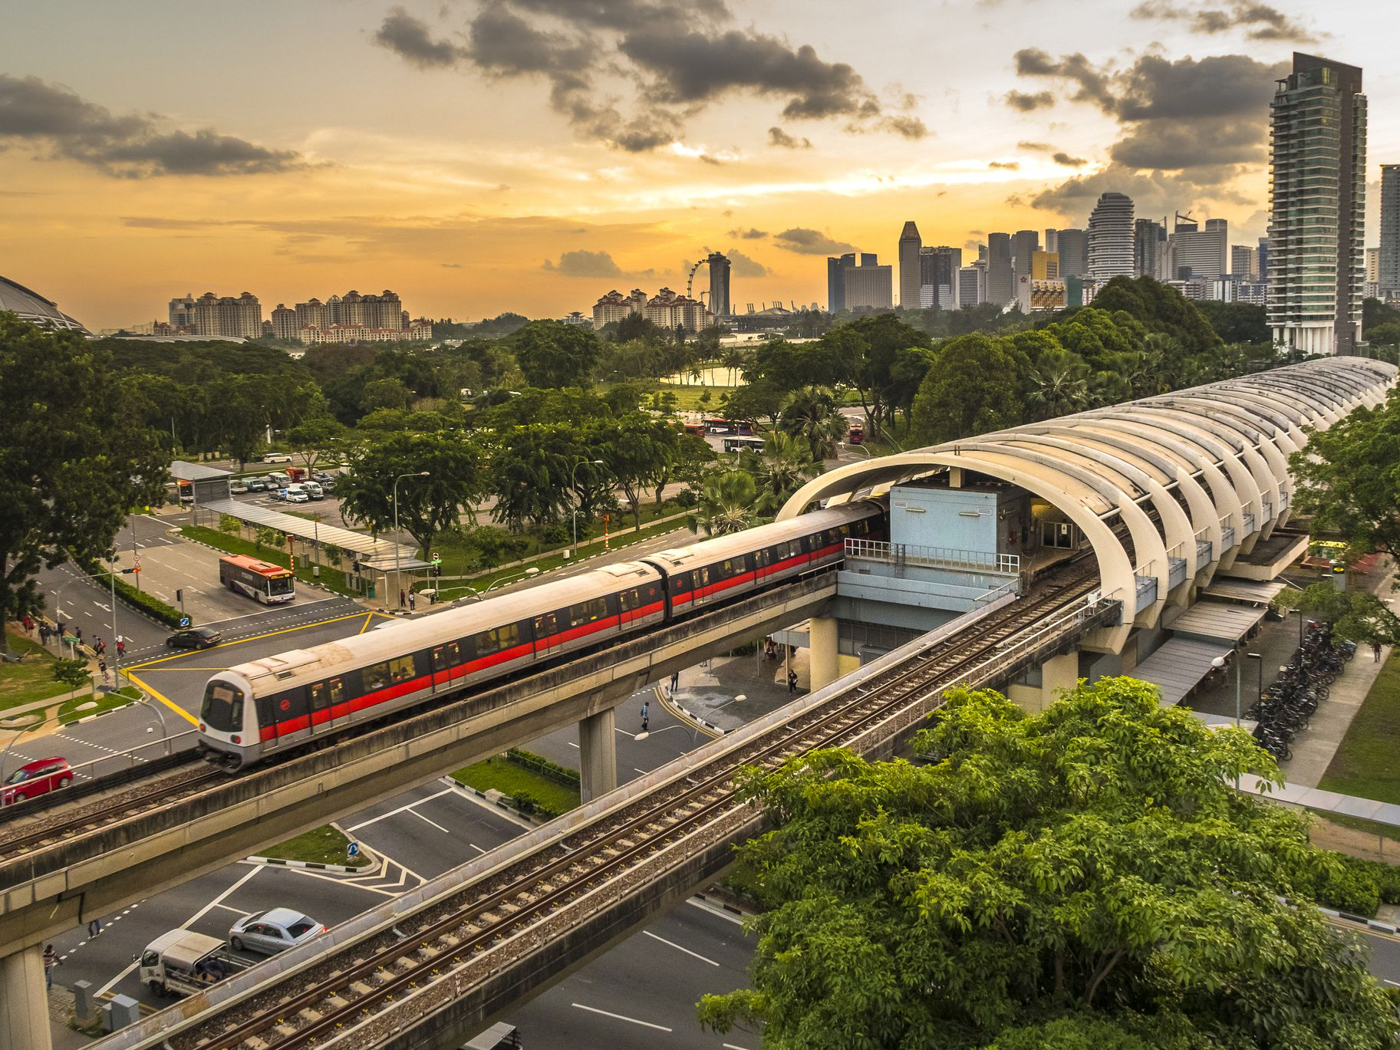
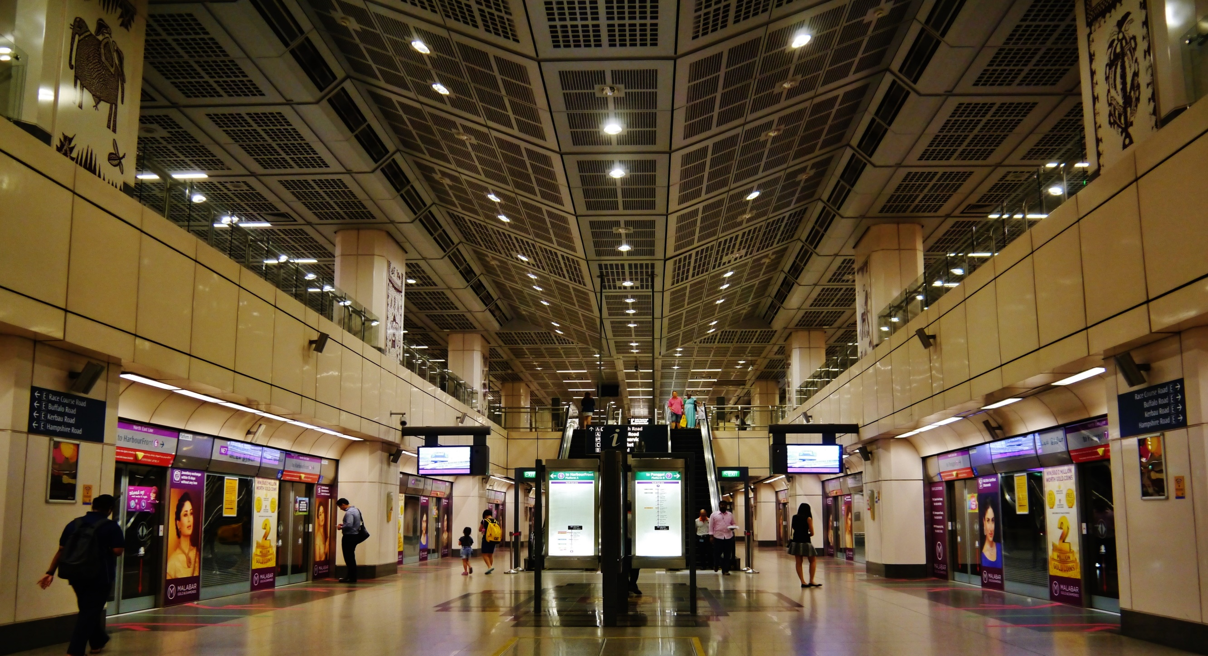

Rail TRANSPORT
A short remaining section of the railway originally built during the British colonial period is connected to the Malaysian rail network, and is operated by Malaysian railway company Keretapi Tanah Melayu (KTM). The Singapore section of the railway now serves only inter-city passenger services; until 2011 the railway also carried freight between Malaysia and the Port of Singapore at Tanjong Pagar.

Two international rail links to Malaysia have been proposed to replace the KTM railway. The Johor Bahru-Singapore Rapid Transit System is currently under construction and is scheduled to begin operations in 2026. The Kuala Lumpur-Singapore High Speed Rail was planned but shelved in January 2021.

Although Singapore is not a member of the International Union of Railways (UIC) given the nature of Singapore as a city-state and its lack of a national railway proper, SMRT Corporation, SBS Transit and the Land Transport Authority are members of the International Association of Public Transport (UITP). SMRT Corporation is also a member of the Community of Metros (CoMET) benchmarking group.

The Mass Rapid Transit, which opened in 1987, is a heavy rail metro system that serves as the major backbone of Singapore's public transport system along with public buses; as of August 2021, the network has a length of 216 km (134.22 mi) and 187 stations. The Land Transport Authority, the main planning authority of the MRT, plans to provide a more comprehensive rail transport system by expanding the rail system to a total of 360 km (223.69 mi) by the year 2030, with eight in ten households living within a 10-minute walking distance of an MRT station.

market size & growth
The current MRT network consists of six main lines: the North South Line, East West Line, Circle Line and partially-opened Thomson–East Coast Line operated by SMRT Trains (SMRT Corporation) and the North East Line and Downtown Line operated by SBS Transit. and two more lines, the Jurong Region Line and the Cross Island Line, will open in stages from 2027 and 2030 respectively.

 | 2018 | 2019 | 2020 | 2021
SBS TARSIT | 1383 | 1445 | 1231 | 1310
SMRT TRAIN | 743 | 737 | 754 | 797
TOTAL | 2126 | 2182 | 1985 | 2107

** The growth forecast is done on the basis of 2 major players SMRT trains Ltd. And SBS tarsit Ltd. Which control nearly 95% of rail operations in Singapore.

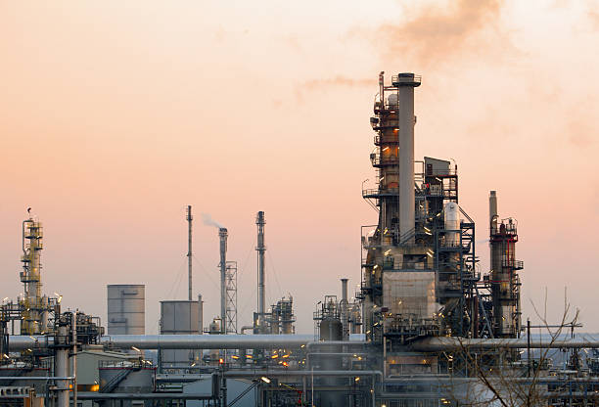

MANUFACTURING
Situated off the southern coast of Singapore is one of the world’s leading chemical manufacturing sites. Over 100 global petroleum, petrochemical and specialty chemical companies are housed on 12 square miles of land; most of which was reclaimed from the ocean in the 1990s as part of an ambitious move by the government to make Jurong Island the premier destination in Asia for multinational chemical companies.

It was a bold plan for a country that does not produce a single drop of oil. Today, Singapore is the world’s fifth largest refinery export hub and amongst the top ten global chemical hubs by export volume.

Innovating to stay ahead of the pack has always been in Singapore’s DNA. That entrepreneurial spirit has fuelled an ecosystem driving some of the most compelling advancements in manufacturing today – from robotics and additive manufacturing, to predictive analytics and artificial intelligence. It has also attracted multinational manufacturing firms to partner Singapore in testing, experimenting and trialling the latest technologies.

One such prominent player is Dyson. Last year, the British manufacturer set up a €360 million (S$578 million) research and development centre in Singapore to develop and implement new Industry 4.0 technologies in its regional facilities. The centre complements its advanced digital motors manufacturing facility in Singapore – Dyson’s first and only such plant in the world.

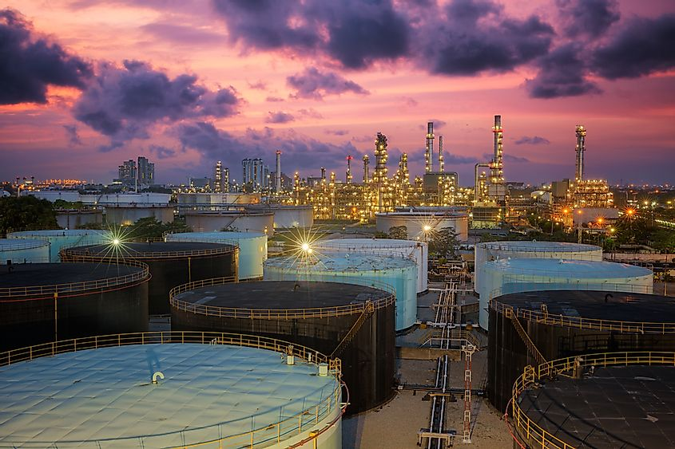

market size & growth
Firstly, Singapore has established a strong base of leading technology and solutions providers, to provide the necessary technical expertise to sustain Industry 4.0 adoption. Some of the biggest industrial names in the world now operate in Singapore – from ABB’s robotics packaging center to Accenture’s IoT Centre of Excellence and Siemens’ first-of-its kind digitalization hub.
Singapore has also committed to invest S$3.2 billion (€2 billion) in R&D in Advanced Manufacturing and Engineering, to build up the innovation capacity of companies embarking on Industry 4.0. Recently, Singapore’s research institutions opened two model factories that help companies accelerate the adoption of Industry 4.0 technologies, by providing a collaborative environment to research and test-bed solutions before deploying them. Through this initiative, industrial equipment supplier Feinmetall successfully achieved productivity improvements of 10 to 15 per cent.

At the time of writing, Singapore’s manufacturing sector makes up approximately 21 percent of the total GDP, totaling around $106 billion. Manufacturing is also significant to the Singapore workforce, employing around 450,000 workers, which equates to about 12% of Singapore’s total employment.

AGRICULTURE
MAJOR FOOD PRODUCTS
- Food crops

Fruits produced in Singapore include durians, rambutans, and mangosteens, while edible fungus produced in the country include mushrooms. There are also farms in the country responsible for the production of eggs, vegetables, poultry, and pork.

- Flower crops

Flowers grown in Singapore are exported to other parts of the world, namely Japan, the United States, Australia, and territories in Western Europe. Such flowers include the orchid. There are 153 orchid farms in Singapore. Plants are mostly cultivated in Singapore for decorative purposes.

- Fishing

Fish grown in Singapore are mostly kept as aquarium fish,[2] though some fish farms rear fish as food items.[3] Qian Hu Corporation Limited is a major fishery in Singapore, farming, exporting, and importing some thousand fish species.[4] On 5 June 2020, the Singapore Food Agency announced that domestic Singapore consumers will eventually be able to buy wholesale seafood at a single location at some time in the coming years, with Jurong Fishery Port and Senko Fishery Port being consolidated by 2023.

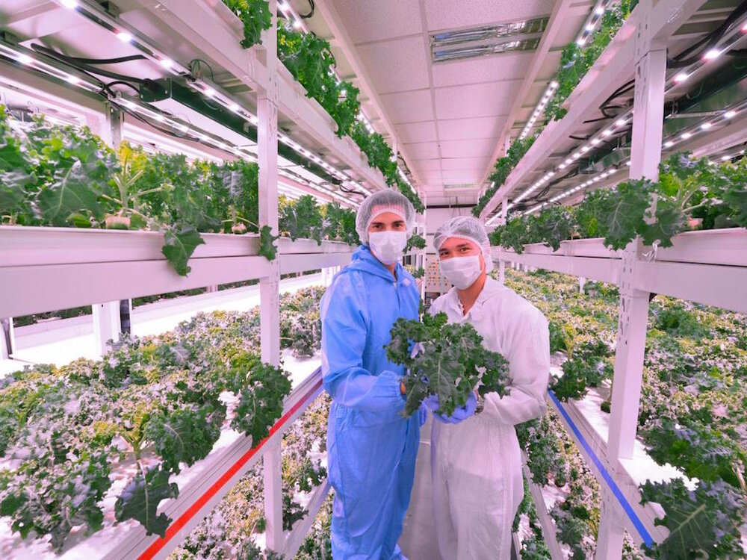
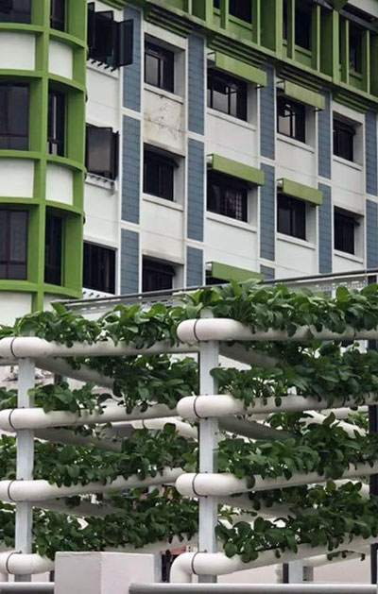

market size & growth
Singapore is one of the two most food import-dependent countries in the world. According to the Global Food Security Index (GFSI), the city-state imports 90% of its food, meeting the shortfall through local production. Urban farming and agritech in Singapore could be the key to solving the country’s consumption needs.

- Urban Farming in Singapore

Because of the potential for such scenarios creating insecurity in the city-state, the Singaporean government has proposed solutions to enhance local food production. Many agencies are involved, including the Singapore Food Agency’s (SFA) grants to boost farm outputs and the Agriculture Productivity Fund’s (APF) million-dollar investments, which will increase farm productivity and capability. Moreover, the Enterprise Singapore (ESG) and the Economic Development Board teamed up to attract or nurture tech-based businesses in the agricultural sector.

In addition, the SFA is pushing the ‘30 by 30’ vision, which aims to meet 30% of the country’s nutritional needs by 2030. It will be complemented by the Singapore Green Plan 2030, whose goal is to ensure a sustainable and resilient food future.

Agritech in Singapore is addressing the food supply question by improving production through innovative solutions. Some of their ideas involve using vertical fish farms, indoor agriculture and rooftop farming. The government is investing $60 million USD to fund startups and provide extra support to the sector.
For agritech in Singapore to advance, the government must invest in the industry and encourage citizens to follow the indoor farming pathway. The small farmland available should not limit people from venturing into agriculture.

With this new mindset, the country can chart a food security path for itself and other countries in Southeast Asia.

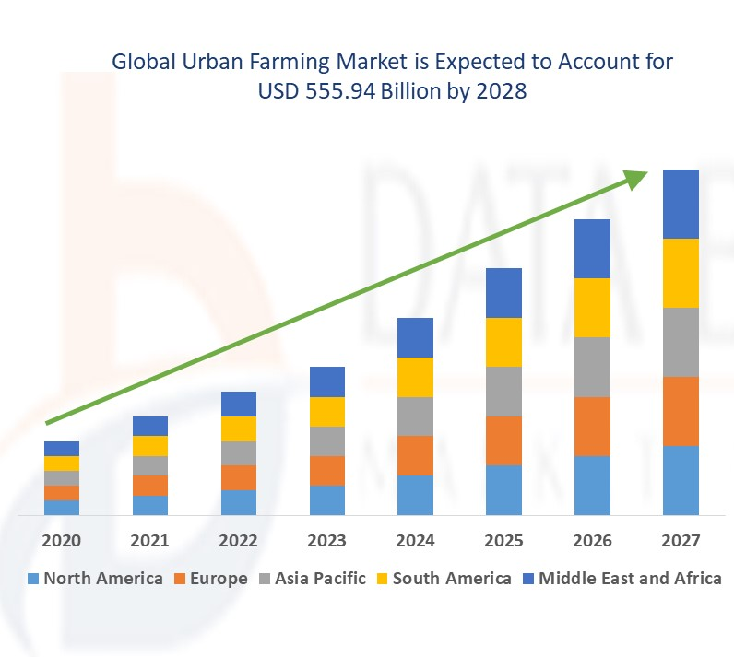
** Above data is taken from Urban Farming Market – Forecast book published in data structure.com research.

References

- https://tradingeconomics.com/singapore/gdp#:~:text=GDP%20in%20Singapore%20averaged%20100.26,0.70%20USD%20Billion%20in%201960
- https://en.wikipedia.org/wiki/Agriculture_in_Singapore#:~:text=Major%20agricultural%20products,-Food%20crops&text=Fruits%20produced%20in%20Singapore%20include,vegetables%2C%20poultry%2C%20and%20pork.
- https://unsplash.com/photos/A3-E4X7qk_0
- https://en.wikipedia.org/wiki/Rail_transport_in_Singapore
- https://www.edb.gov.sg/en/business-insights/insights/singapore-a-leading-manufacturing-hub.html#:~:text=Today%2C%20Singapore%20has%20built%20a,per%20cent%20to%20its%20GDP.
- https://www.rikvin.com/blog/manufacturing-sector-singapore-development-plans/
- https://www.smrt.com.sg/Portals/0/SMRT_OpsReview2020_Full_16042021.pdf
- https://www.sbstransit.com.sg/Uploads/Investor_Relations/Annual_Report/2021/4.%20SBS%20Transit%20AR%202021%20-%20Full.pdf
- https://www.entrepreneur.com/article/376572
- https://www.istockphoto.com/photos/india-industry
- https://www.statista.com/statistics/1304192/singapore-manufacturing-output-by-industry-cluster/
- https://www.aseanbriefing.com/news/aseans-leading-manufacturing-destinations/
- https://www.researchandmarkets.com/reports/3920006/urban-farming-market-forecast-2020-2025
- https://www.databridgemarketresearch.com/reports/global-urban-farming-market
- https://techcollectivesea.com/2021/11/24/urban-farming-singapore/

